Electronic Structure Family Feud: Mechanism 1 vs. Mechanism 2

Coral I. Pichardo, ‡Justyn Cespedes

*ST. JOHN’S UNIVERSITY*

**ABSTRACT:** For the given reaction shown in Figure 1, two different mechanisms were proposed. Mechanism 1 is shown in Figure 2 and Mechanism 2 is shown in Figure 3. The purpose of this experiment is to show that one mechanism is more thermodynamically favorable than the other. This can be shown by measuring the energy values of each mechanism. Electronic structure calculations were made through Gauss View for each molecule involved in each mechanism. With these calculations the thermodynamics of both mechanisms were compared. It was determined that Mechanism 2 is more thermodynamically favorable.

Scheme 1. Dehydration Reaction



Scheme 2. Mechanism Scheme 3. Mechanism 2

 

**INTRODUCTION:**

When comparing the validity of two different mechanisms with the same starting reagent and same final product, the thermodynamics of each mechanism should be called into question. If a mechanism is considered thermodynamically favorable, then it is more likely to take place in nature. We can tell how thermodynamically favorable a given mechanism is using the Gibbs Free Energy Equation:

**Equation 1: $∆G°=∆H°-T∆S°$**

Where ΔG° is the change in free energy of a given reaction, ΔH° is the change in enthalpy, and ΔS° is the change in entropy. When ΔG° is negative for a given reaction, this means that it is thermodynamically favorable as well as spontaneous. The spontaneity of a reaction is dependent on signs of both the enthalpy and entropy. If ΔH° is negative and ΔS° is positive, then the reaction is always spontaneous. If both ΔH° and ΔS° are positive, then the reaction is spontaneous at higher temperatures and non-spontaneous at lower temperatures. If both ΔH° and ΔS° are negative, then the reaction is spontaneous at lower temperatures and non-spontaneous at higher temperatures. If ΔH° is positive and ΔS° is negative, then the reaction is always non-spontaneous. A reaction is enthalpically driven if both ΔH° and ΔS° are negative at high temperatures. A reaction is entropically driven if both ΔH° and ΔS° are positive at high temperatures. All the terms in the Gibbs Free Energy Equation can be calculated and obtained through Gaussian 16.

**COMPUTATIONAL DETAILS (METHODS):**

For each molecule, the job type was first set to “Optimization” and ran under a 3-21G basis set using a Hartree-Fock method. Once the optimization of each molecule was run, the job type was changed to “Energy”. Under the “Energy” job type, the method was changed to DFT. The basis set was consecutively changed from, 3-21G, 6-31G, 6-311G. After each of these “Energy” jobs were run for each molecule, the next and final job type used was “Opt-Freq”. Under the “Opt-Freq” job type, the method remained as DFT, and the basis set was 6-311G with 2d and 2p orbitals included. For all of these

calculations, if a given molecule had a charge it was included under the basis set in the calculation set up. From each of these “Opt-Freq” runs, the .log file was opened to obtain the Thermo values from the results summary. Values for the Internal

Energy, Free Energy, Enthalpy and Entropy were noted for each molecule.

**RESULTS AND DISCUSSION:**

Each molecule in each mechanism was labelled in such a way that indicated which mechanism it belonged to as well as which step in the mechanism it was. For example, the first molecule in Mechanism 1 was labelled “1_1” while the second molecule in the same mechanism was labelled “1_2” and so on. Water and H3O+ were labelled as such. Table 1 shows all of the values obtained from Gaussian 16. Although the values were originally given in Hartree units in Gaussian 16, the values shown in Table 1 were converted to Kcal/mol.

**Table 1. Gaussian obtained values for each molecule involved in each mechanism (Kcal/mol)**

|  |  |  |  |  |
| --- | --- | --- | --- | --- |
|  | Internal Energy | Free Energy | Enthalpy | Entropy |
| 1_1/  2_1 | -388830.258 | -388862.775 | -388829.665 | 0.111052 |
| 1_2/  2_2 | -389074.243 | -389107.619 | -389073.650 | 0.11393 |
| 1_3 | -341122.445 | -341154.480 | -341121.853 | 0.109431 |
| Final | -341619.560 | -341650.616 | -341618.967 | 0.10615 |
| H2O | -47943.131 | -47955.988 | -47942.539 | 0.04511 |
| H3O+ | -48188.065 | -48201.637 | -48187.473 | 0.047507 |

Molecules that were consistent in both mechanisms, such as the starting molecule and the final product, produced the same values and so were grouped together in Table 1. For each mechanism the change in energy between each step was calculated by subtracting the sum of reactants from the sum of products using the values from Table 1. The change in Internal Energy, Free Energy, Enthalpy and Entropy for Mechanism 1 is shown in Table 2.

**Table 2. Change in Energy, Enthalpy, and Entropy for Mechanism 1 (Kcal/mol)**

|  |  |  |  |  |
| --- | --- | --- | --- | --- |
|  | ΔInternal Energy | ΔG° | ΔH° | ΔS° |
| 1_1 → 1_2 | 0.948795 | 0.805095 | 0.948794 | 0.000481 |
| 1_2 → 1_3 | 8.665908 | -2.849522 | 9.258279 | 0.040611 |
| 1_3 → Final | -742.04831 | -741.7854 | -742.0483 | -0.000884 |
| Overall | -732.43361 | -743.8298 | -731.8412 | 0.040208 |

Going from 1_1 to 1_2 we can see that both ΔH° and ΔS° are positive, as well as ΔG°, meaning this process is non-spontaneous. However, at higher temperatures, this process would not only be spontaneous, but also entropically driven. Going from 1_2 to 1_3 shows ΔH° and ΔS° as positive again, except ΔG° is negative, meaning this process is spontaneous and entropically driven. Going from 1_3 to the final product both ΔH° and ΔS° are negative, as well as ΔG°, meaning this process is spontaneous. At higher temperatures, this process would be non-spontaneous and enthalpically driven. The change in Internal Energy, Free Energy, Enthalpy, and Entropy for Mechanism 2 is shown in Table 3. Since both mechanisms have the same start and end points, the overall change in energy is the same in both. The difference between the mechanisms is evident in the different changes of energy for the individual steps it takes to get to the final product.

**Table 3. Change in Energy, Enthalpy, and Entropy for Mechanism 2 (Kcal/mol)**

|  |  |  |  |  |
| --- | --- | --- | --- | --- |
|  | ΔInternal Energy | ΔG° | ΔH° | ΔS° |
| 2_1 → 2_2 | 0.948795 | 0.805095 | 0.948794 | 0.000481 |
| 2_2 → Final | -733.38240 | -744.6349 | -732.79003 | 0.039727 |
| Overall | -732.43361 | -743.8298 | -731.8412 | 0.040208 |

The first process in Mechanism 2 produces the same values as Mechanism 1 and so this process is also non-spontaneous but would be spontaneous and entropically driven at higher temperatures. Going from 2_2 to the final product ΔH° is negative and ΔS° is positive with ΔG° being negative, meaning this process is spontaneous at all temperatures. The overall reaction for both mechanisms have a negative ΔH°, a positive ΔS°, and a negative ΔG°. This means that the overall reaction is spontaneous at all temperatures. A more visual comparison of the change in Free Energy for each mechanism can be seen in Figure 1.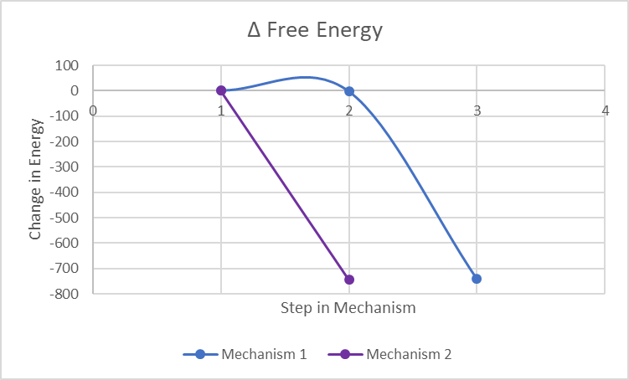

**Figure 1. Change in Free Energy for Mechanisms 1 and 2**

Although the first step in both mechanisms are equal, the second step is vastly different between the two. Mechanism 2 has a much lower change in free energy in the second step than Mechanism 1. Figure 1 shows that Mechanism 1 undergoes an increase in energy in step 2 before it is able to reach the same low energy as Mechanism 2 in its final step.

**CONCLUSION**

Seeing as the calculations were measured at 298K and the majority of the steps for each mechanism would be entropically driven at higher temperatures, this would mean that the overall reaction for both mechanisms are also entropically driven at the higher temperatures required for this reaction to occur. Additionally, the lower the energy required for a reaction to occur, the more likely it will occur in nature. Both mechanisms may start off with the same energy, but Mechanism 1 has to overcome a state of higher energy to even get to the low energy state of the final product, whereas Mechanism 2 easily goes straight into a lower energy state and reaches the final product using less energy. Based on thermodynamics, the data here shows that Mechanism 2 is more thermodynamically favorable than Mechanism 1.

**SUPPORTING INFORMATION**

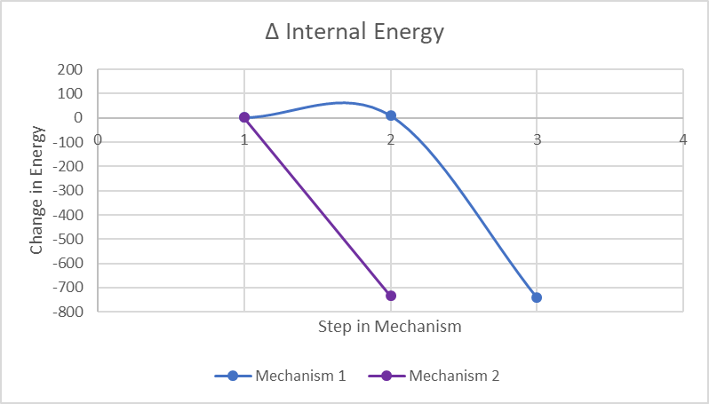

**Figure 2. Change in Internal Energy for Mechanisms 1 and 2**

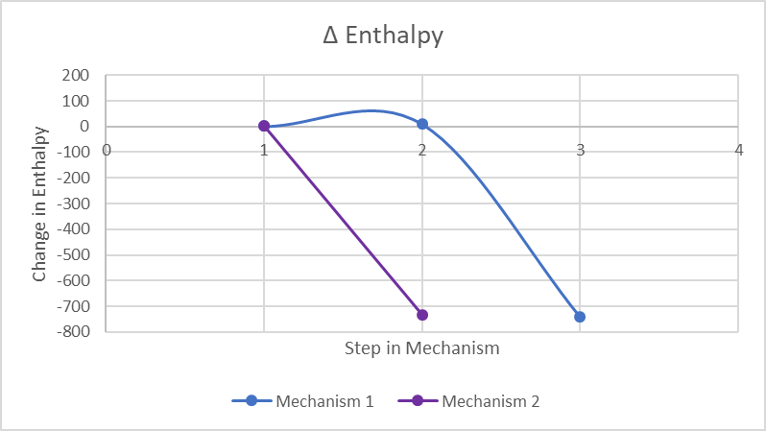

**Figure 3. Change in Enthalpy for Mechanisms 1 and 2**

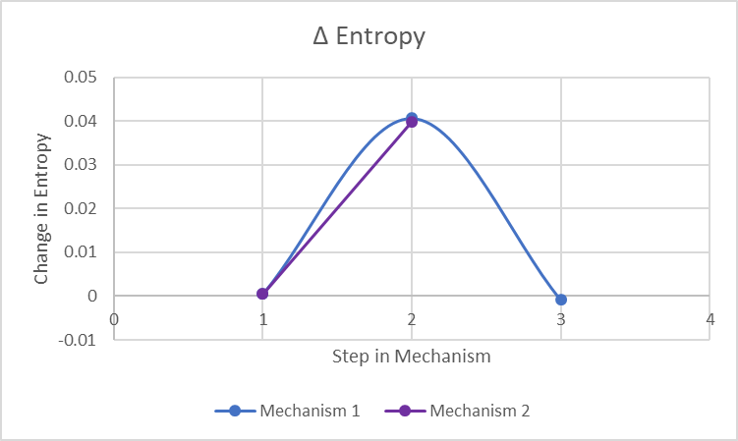

**Figure 4. Change in Entropy for Mechanisms 1 and 2**

**AUTHOR CONTRIBUTIONS**

The manuscript was written through contributions of all authors. All authors have given approval to the final version of the manuscript. ‡These authors contributed equally to the first author.

**FUNDING SOURCES**

The Clare Boothe Luce Graduate Fellowship

**REFERENCES**

1. Citation | Gaussian.com https://gaussian.com/citation/ (accessed Nov 17, 2019).
2. Journal of Chemical Theory and Computation : https://pubs.acs.org/page/jctcce/submission/authors.html#TEMPLATES (accessed Nov 1, 2019).
3. 6.2: A Quick Review of Thermodynamics and Kinetics https://chem.libretexts.org/Bookshelves/Organic_Chemistry/Book%3A_Organic_Chemistry_with_a_Biological_Emphasis_v2.0_(Soderberg)/6%3A_Overview_of_Organic_Reactivity/6.2%3A_A_Quick_Review_of_Thermodynamics_and_Kinetics (accessed Nov 4, 2019).
4. 11.5: Spontaneous Reactions and Free Energy https://chem.libretexts.org/Courses/University_of_Kentucky/UK%3A_CHE_103_-_Chemistry_for_Allied_Health_(Soult)/Chapters/Chapter_11%3A_Properties_of_Reactions/11.5%3A_Spontaneous_Reactions_and_Free_Energy (accessed Nov 15, 2019).
5. 19.6: Free Energy and Temperature https://chem.libretexts.org/Bookshelves/General_Chemistry/Map%3A_Chemistry__The_Central_Science_(Brown_et_al.)/19%3A_Chemical_Thermodynamics/19.6%3A_Free_Energy_and_Temperature (accessed Nov 15, 2019).